Internationalization

and

location

Summary
What Is It?
- Internationalization
- Location

How Does It Works?
- Bundle
- Standard Codes

How Do We Implement It
- Folder creation
- Properties implementation
- I18NBundle class and buttons
- Project Review

What is it?
Internationalization
- Process of designing a software so that it can potentially be adapted to various languages and regions without engineering changes
- Abbreviation i18n

Location
- Process of adapting internationalized software for a specific region or language by adding locale-specific components and translating text.
- Abbreviation i10n
- Be aware of different cultures

how does it works
Bundle
- A bundle is a set of properties files that share the same base name
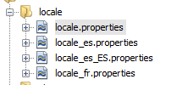
- I18NBundle class
- Default properties and others
startmenu.play = play
startmenu.statistics = stats
startmenu.exit = Exit

how does it works
Standard Codes
- Iso 639 is a standardized nomenclature used to classify languages
- Iso 3166-1 is another standardized nomenclature that defines codes for the names of countries

How do we implement it
First we’re going to create a bundle.
We move to our assets folder and create a folder called locale

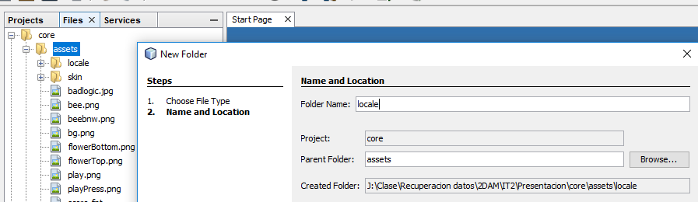

How do we implement it
Now, we add a property file inside our locale folder and we called it locale.properties
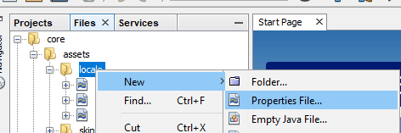
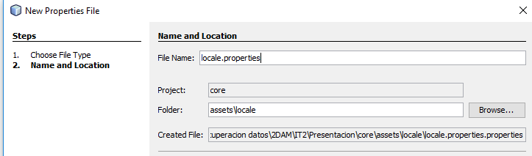

How do we implement it
This is gonna be our default language property
In this project, we have a screen with 3 buttons, so we add the same amount of properties to this file
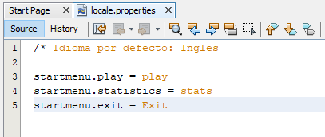

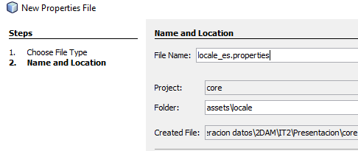
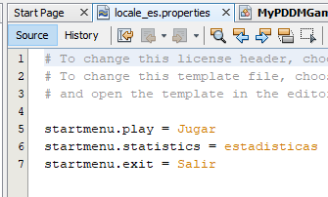
So, we create a new locale with our language code, based on Iso 639

How do we implement it
Now we move to our main project and create our bundle with I18NBundle and add 3 buttons
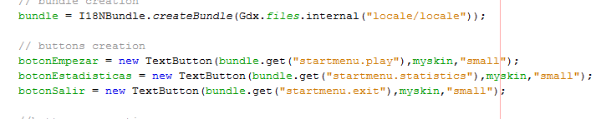
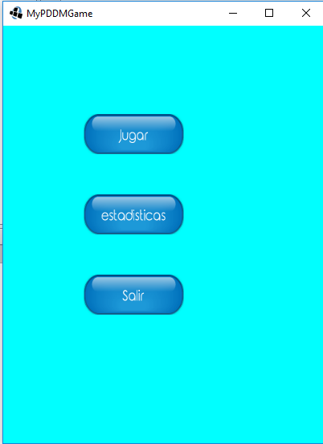
Finally, we run the game

